Phase 4: Transitional Reading 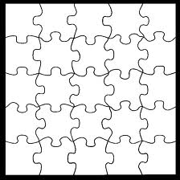
I can tell other people what a book was about, whether it was a story or an information book.

I can give people more detailed information about a book if they ask for it.

I can tell people what I think about a book and whether I
agree or disagree
with what it says.

I can guess what is going to happen in a book and say why.

I can sound words out.

I can use my voice to show the meaning when I read aloud.
I can tell when I’ve made a mistake and put it right.

I can read words which I can’t sound out because I know how the letters go together e.g. sh, ch.
I can guess a word because I know another one like it e.g. circle, circuit.
I can understand why capital letters, full
stops, commas, exclamation marks and speech marks are used..

I like reading for pleasure.
I can have a go at reading words I don’t know.
I like having a go at books which are interesting but a bit hard..

I can tell when an author is trying to make me think about something his or her way.

I like thinking about whether a book is
like real life or
whether it is just the way the author sees it.
I like reading to find things out.

I can break a word down into syllables.
I like talking about books and the way they make me feel.

I like particular books and authors.

I can tell people why I think the way I do about a book.

RW

.

I

.
RW

.

.
.

